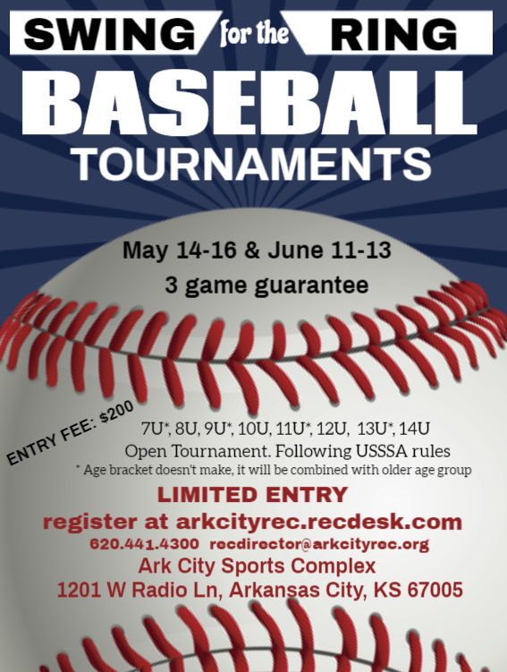

Ark City Baseball Tournament
2021
“Swing for the Ring”
Ark City Sport Complex
1200 West Radio Lane, Arkansas City, KS 67005

Dates: May 14-16 June 11-13

Format: 3-game guarantee; Pool Play, Single Elimination Bracket. Following USSSA Rules

Fee: $200 per team per tournament

Divisions: 7U* Coach Pitch, 8U Coach Pitch, 9U*, 10U, 11U*, 12U, 13U*, 14U
* Age bracket does not make it will be combined with older age group

Location: Ark City Sports Complex, 1201 West Radio Lane, Arkansas City, KS 67005

Deadlines: Team entry fee must be paid to secure entry into the tournament.

Admission: Adult $5; Student $3; Under 5 Free

Tournament Host:
Arkansas City Recreation Commission
Phone (620) 441-4300 Office / (316) 680-3722 Cell
Fax (620) 442-1540 / Email: recdirector@arkcityrec.org
Address: Arkansas City Rec Center, 225 East 5th Ave., Arkansas City KS 67005
Online Registration: arkcityrec.recdesk.com
You must add an account to complete the registration process. If mailing a check, please
make payable to ACRC.

Division Team Name

Coach Name

Phone # Email

Office Only:

Tourney Date Team Name Division

Check # Credit Card # & Exp Date

Date Amount Received by

